D-latch. D-flip-flop. Registers.
- The D Latch
- The D Flip-Flop
- Flip-Flop Symbols
- Serial to Parallel Shift register
- Parallel to Serial Shift register
P&H Appendix-B, Wakerly Ch.7

- Goal – Teach students how to create and use D- latches, D-flip-flops, registers, cascades of registers.
- Learning outcome - by the end of this class the students should be able to create RTL schematic.

f

The D Latch
One very useful variation on the RS latch circuit is the Data latch, or D latch as it is generally called. As shown in the logic diagram below, the D latch is constructed by using the inverted S input as the R input signal. The single remaining input is designated "D" to distinguish its operation from other types of latches. It makes no difference that the R input signal is effectively clocked twice, since the CLK signal will either allow the signals to pass both gates or it will not.

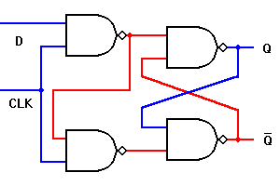 | D Q  _  Q
  CLK | D | Q | Qn
  0 | D | Q | Q
  1 | D | Q | D

Timing diagram of D latch.

D

CLK

QA

In the D latch, when the CLK input is logic 1, the Q output will always reflect the logic level present at the D input, no matter how that changes. When the CLK input falls to logic 0, the last state of the D input is trapped and held in the latch, for use by whatever other circuits may need this signal.
Because the single D input is also inverted to provide the signal to reset the latch, this latch circuit cannot experience a "race" condition caused by all inputs being at logic 1 simultaneously. Therefore the D latch circuit can be safely used in any circuit.
Although the D latch does not have to be made edge triggered for safe operation, there are some applications where an edge-triggered D flip-flop is desirable. This can be accomplished by using a D latch circuit as the master section of an RS flip-flop, as shown on next page. Both types are useful, so both are made commercially available.
Except for the change in input circuitry, a D flip-flop works just like the RS flip-flop.

The D Flip-Flop

The edge-triggered D flip-flop is easily derived from its RS counterpart. The only requirement is to replace the R input with an inverted version of the S input, which thereby becomes D. This is only needed in the master latch section; the slave remains unchanged.

One essential point about the D flip-flop is that when the clock input falls to logic 0 and the outputs can change state, the Q output always takes on the state of the D input at the moment of the clock edge. This was not true of the RS and JK flip-flops. The RS master section would repeatedly change states to match the input signals while the clock line is logic 1, and the Q output would reflect whichever input most recently received an active signal. The JK master section would receive and hold an input to tell it to change state, and never change that state until the next cycle of the clock. This behavior is not possible with a D flip-flop.
The edge-triggered D NAND flip-flop is shown below.

Slave RS latch
Master D latch
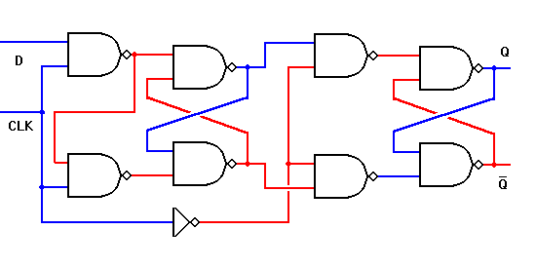

q

CLK’
Timing diagram of edge-triggered RS NAND Flip-Flop. R and S work only if CLK goes from 1 to 0.

D

CLK

qA

CLK’

QA

Flip-Flop Symbols

Although the internal circuitry of latches and flip-flops is interesting to watch on an individual basis, placing all of those logic symbols in a diagram involving multiple flip-flops would rapidly generate so much clutter that the overall purpose of the diagram would be lost. To avoid this problem, we use the "black-box" approach. This is actually just one step further that the "black-box" approach we used in specifying logic gate symbols to represent specific clusters of electronic components — now we are using one symbol to represent a cluster of logic gates connected to perform a specific function.
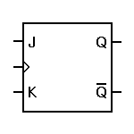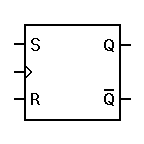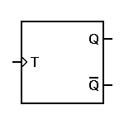
As you have no doubt noticed, the symbols above are nearly identical — only the inputs vary. This is typical of the "black-box" approach. However, there is one other variation, as shown below.
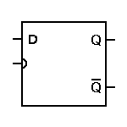
In each of the symbols above, the clock input is marked by the small angle, rather than by the letters CLK. That little angle marker actually provides two pieces of information, rather than one. First, of course, it marks the clocking input. Second, it specifies that these are edge-triggered flip-flops. The D latch shown to the right uses a rounded marker for the clock input. This signifies that the circuit is controlled by the clock level, not the clock edge. In fact, the symbol to the right would normally be used for the D latch circuit shown separately. If we change that rounded input to a sharp angle, it would indicate an edge-triggered master-slave D flip-flop.

Any of these symbols may be modified according to their actual use within the larger circuit. For example, if only the Q output is used, it may well be the only output shown. Some flip-flops incorporate master preset or reset inputs, which bypass the clock and the master section of an edge-triggered flip-flop and force the output to an immediate known state. This is often used when a circuit comprised of many flip-flops is first powered up, so that all circuits will start in a known state.

It is very seldom that a flip-flop will actually be used alone. Such circuits are far more useful when grouped together and acting in concert. There are two general ways in which flip-flops may be interconnected to perform useful functions: counters and registers. When we're done with individual flip-flops, we'll go on to counters and then look at registers.

Serial to Parallel Shift register

The term register can be used in a variety of specific applications, but in all cases it refers to a group of flip-flops operating as a coherent unit to hold data. This is different from a counter, which is a group of flip-flops operating to generate new data by tabulating it.

In this context, a counter can be viewed as a specialized kind of register, which counts events and thereby generates data, rather than just holding the data or changing the way it is handled. More commonly, however, counters are treated separately from registers. The two are then handled as separate concepts which work together in many applications, and which have some features in common.

The demonstration circuit below is known as a shift register because data is shifted through it, from flip-flop to flip-flop. If you apply one byte (8 bits) of data to the initial data input one bit at a time, and apply one clock pulse to the circuit after setting each bit of data, you will find the entire byte present at the flip-flop outputs in parallel format. Therefore, this circuit is known as a serial-in, parallel-out shift register. It is also known sometimes as a shift-in register, or as a serial-to-parallel shift register.

By standardized convention, the least significant bit (LSB) of the byte is shifted in first.

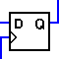

Parallel to Serial Shift register

Where there is a need for serial-to-parallel conversion, there is also a need for parallel-to-serial conversion. The parallel-in, serial-out register (or parallel-to-serial shift register, or shift-out register), however, is a bit more complex than its counterpart. Since each flip-flop in the register must be able to accept data from either a serial or a parallel source, a small two-input multiplexer is required in front of each input. An extra input line selects between serial and parallel input signals, and as usual the flip-flops are loaded in accordance with a common clock signal.

The shift-out demonstration circuit below is limited to four bits so it can fit horizontally on a reasonable page. This is also a practical size for commercial ICs. A 4-bit shift register with parallel and serial inputs and outputs will fit nicely into a 14-pin DIP IC.

In addition, this demonstration circuit introduces a new input button: a mode control. The button labeled "S" indicates that the shift-out register is currently in serial mode. Thus, input signals present at the serial input just above the "S" button will be shifted into the register one by one with each clock pulse. If you click on the "S" button, it will change state as expected, but will also change to a "P" to indicate that the register now operates in parallel mode. This enables you to load the entire register at once from the parallel inputs just below the multiplexers. Thus, we can have a parallel input and a serial output. The inclusion of a serial input makes it possible to cascade multiple circuits of this type in order to increase the number of bits in the total register. This is common practice in real-world circuits.

Because this circuit has both parallel and serial inputs and outputs, it can serve as either a shift-in register or a shift-out register. This capability can have advantages in many cases.

The least significant bit (LSB) is always available first at the serial output.

